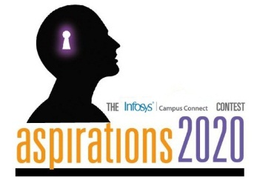 

**Aspirations2020 State Finals**

**Student Travel Itinerary**

Dear Student,

As a winner of the college round of the Aspirations2020 contest, you are invited to the Infosys campus in Bangalore to participate in the DC (state) finals.

**Date:** Tuesday, 30th September, 2014

**Location:** Infosys Limited., No. 44, Electronics City, Hosur Road,

Bangalore - 560 100.

**Time:** 7:00 AM to 5 PM. Please report at Gate 6.

**Venue:** Audi 1, Ground Floor, Building 12.

This document contains details of your travel and accommodation for the event. Please furnish your detailed itinerary in the format below and mail it to [Sahana_Kumaraswamy@infosys.com](mailto:Sahana_Kumaraswamy@infosys.com) by Monday, **29th September, 2014**. **Please carry your college identity card. Entry into the campus will strictly not be allowed without ID card.** Each teammay be accompanied by the Campus Connect SPoC of the college.

**Note to Outstation candidates:** Please make it convenient to reach the Infosys Campus directly one day prior to the event and book the return tickets so that the journey starts after 6:00 pm on Tuesday, 30th September, 2014.

|  |  |  |  |
| --- | --- | --- | --- |
| **Arrival at Infosys** | | | |
| Student Name: | Rahul R | | |
| Institution Name: | RVCE | | |
| From: | Town Hall, Bangalore | To: | Infosys Limited., No. 44, Electronics City |
| Mode: | TAXI | Class of Travel: | A/C |
| Date of departure: | 29-10-2014 | Time of departure: | 03:00 PM |
| Train/Bus number: |  | Expected time of arrival: | 5:45 PM |

|  |  |  |  |
| --- | --- | --- | --- |
| **Departure from Infosys** | | | |
| Student Name: | Rahul R | | |
| Institution Name: | RVCE | | |
| From: | Infosys Limited., No. 44, Electronics City | To: | Town Hall, Bangalore |
| Mode: | TAXI | Class of Travel: | A/C |
| Date of departure: | 30-10-2014 | Time of departure: | 02:30 PM |
| Train/Bus number: |  | Expected time of arrival: | 05:15 PM |

|  |  |  |  |
| --- | --- | --- | --- |
| **Accommodation required (Yes/No):** | |  | |
| If Yes, | | | |
| From (Date, Time): | 29-10-2014, 06:00 PM | To (Date, Time): | 30-10-2014, 02:30 PM |

Please note the following with respect to travel and accommodation:

1. Infosys will reimburse your travel expenses from your institution to the campus and back for shortlisted teams. Reimbursement will be made as per the travel policy and guidelines. Participants are entitled to reimbursement as per actual up to sleeper train or Non-A/C Bus ticket on presenting the originals*.*
2. To reach the venue, participants may travel by a higher/different class. However, only Sleeper class train expenses or Non-A/C bus amount will be reimbursed. Actuals will be reimbursed based on actual amount verification. Students must submit original **onward journey** tickets and photo copies of **return journey** tickets.
3. Infosys will provide accommodation on campus for the duration of the event for participants.
4. Please note that other faculty/parents/guests will have to make their own travel and accommodation arrangements.

**Please note the following w.r.t. arrival at Infosys:**

1. It is advised to reach Infosys Campus one day prior to the event i.e. by 6:00 PM, Monday, 29th September, 2014 through Gate 6. Accommodation will be arranged at Infosys.
2. On the day of the event, please report no later than 7:00 AM on Tuesday, 30th September, 2014 at Audi 1, Ground Floor, Building 12. Breakfast will be arranged at Dining Hall, 2nd Floor, Building 11.
3. Please bring your college identity card without fail.
4. Please do not carry any laptops/hardware/CDs/pen drives to the Infosys campus.

Contact Details:

|  |  |  |
| --- | --- | --- |
| Team | Contact Person | Telephone number |
| Program Point of contact (Logistics) | Tejashwini | +91 - 9886641970 |
| Gate Security (24x7) | Security | 080 – 2852 0261 Ext:51999 |
| Accommodation (24x7) | Accommodation Desk | 080 - 41412998 |
| Campus Connect | Sahana Kumaraswamy | +91 - 9739917124 |
|  | Vani K N | +91 - 7829185549 |

Following softwares will be available for the Contest:

Browser: IE7 or above or chrome

Windows 7 / Windows XP

•         For C/CPP coders – Visual Studio 2005 or any later versions

•         For Java coders –JDK 6.0 or any later versions

•         CodeBlocks, Eclipse and Netbeans IDE

Please indicate in your response that you have read and understood the terms and conditions in this document.

Below is the route map from the Bangalore Railway station to the Infosys campus in Electronics City.

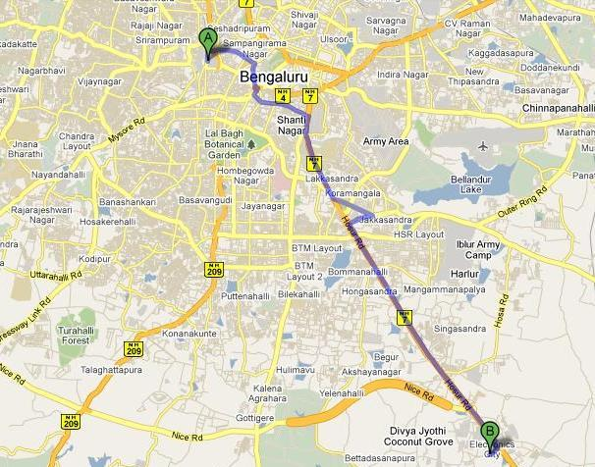

**Aspirations2020-Online Programming Contest-2014-Details of Inter-College Winners**

Dear Participant,

Please share the following information with us for our records. We appreciate your time for the same.

1. Name: Rahul R
2. College Name and address: RVCE, Mysore Road, Bangalore-560059
3. Branch and year of engineering: Information Science, 4th year
4. Insert your passport size photo soft copy

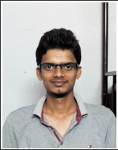

1. Email ID: rahul.rvce.is@gmail.com
2. Mobile phone number: 8123735148
3. Your residential address with land line number: SRNG Sampannappa Hostel, #1091,

OTC Road, Bangalore-560002

1. Brief note on your Hobbies: Coding.

Chess, Table Tennis, Cricket.

Music, Bike Riding, Trekking, Travelling.

1. Areas of Interest:
   1. Algorithms
   2. Information Retrieval
   3. Machine Learning
2. Key Achievements:
   1. 2nd best paper award for "Efficient Implementation of Dictionary using Ternary Search Tree" at Computer Society of India 27th Convention.
   2. Won coding contests in PESIT, UVCE, HKBK.
   3. Selected for pre-FIRE workshop: There was a task of ' Locating Named Entities in a set of million queries' , to be completed to go into the workshop conducted by **Microsoft Research India**.
3. Job Preferences:
4. Your role model: My Family
5. Provide an instance/situation where you have demonstrated your
   1. Analytical skills,
   2. Communications skills, I spoke in many hostels in Bangalore on representing my hostel
   3. Articulation skills,
   4. Planning and organizing skills,
   5. Creativity,
   6. Innovation, Automatic online judging system introduction to various hostels

* 1. Team Work, My projects

1. Any other comments/suggestions that you would like to share with us: